Tavily Search API
API Key Generation — Setup Guide

Purpose | Step-by-step guide to generate a Tavily Search API key
Website | https://tavily.com

Introduction
Tavily provides a powerful real-time search, extraction, research, and web crawling API for AI agents. This document walks you through the process of creating an account on Tavily and generating your API key, which is required to authenticate your API requests.
The free Researcher plan includes 1,000 API credits per month, which is sufficient for development and testing purposes.

Prerequisites
- A web browser (Chrome, Firefox, Edge, etc.)
- A Google or GitHub account (for quick sign-up), or a valid email address

Step 1 | Navigate to Tavily and Sign Up

1.1 Open your web browser and navigate to tavily.com.
1.2 On the Tavily homepage, locate the "Sign Up" button in the top-right corner of the navigation bar.
1.3 Click the "Sign Up" button to proceed to the registration page.

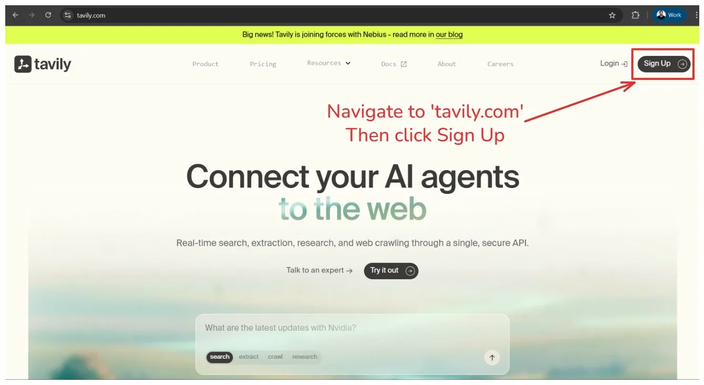

Step 2 | Create Your Account

2.1 On the Welcome/Login page, you will see options to sign up using your email address or through social login providers.
2.2 Click "Continue with Google" (recommended) or "Continue with GitHub" for quick registration. Alternatively, enter your email address and complete the CAPTCHA to sign up manually.
2.3 If using Google sign-in, a popup will appear asking you to choose your Google account. Select the account you wish to use.
2.4 Review the permissions and click the "Continue" button to authorize Tavily and complete account creation.

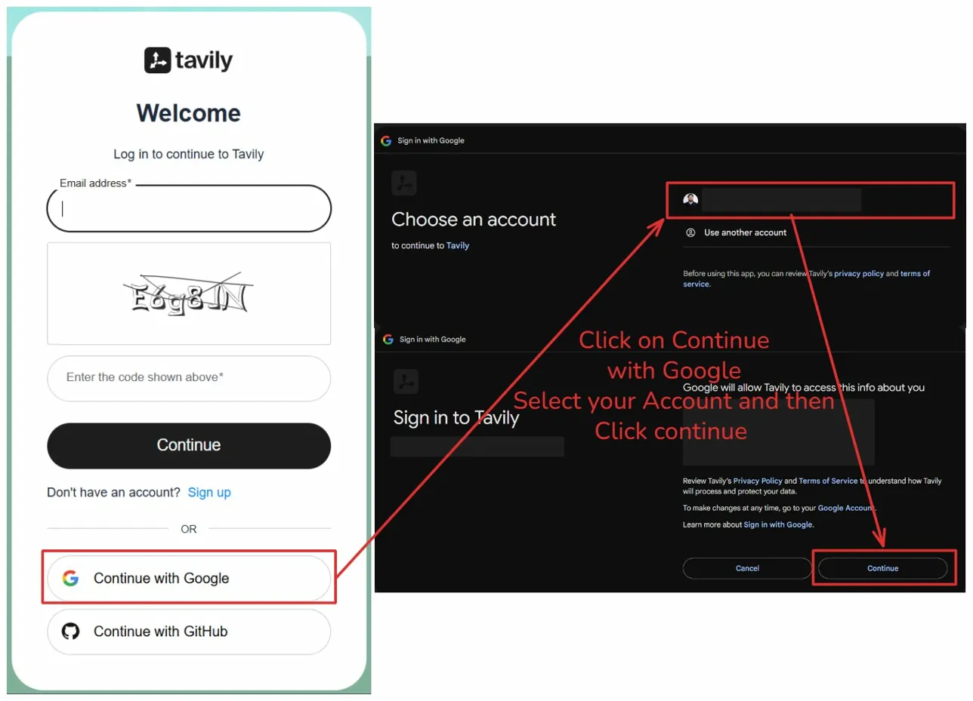
Insert screenshot here

Step 3 | Copy Your Default API Key

3.1 After signing in, you will be redirected to the Tavily Dashboard at app.tavily.com/home. You will land on the Overview page.
3.2 Your account will be on the free "Researcher" plan by default, which includes 1,000 API credits per month.
3.3 Scroll down to the "API Keys" section. A default API key (named "default", type "dev") has been automatically generated for you.
3.4 Click the copy icon next to the API key to copy it to your clipboard. The key will be in the format: tvly-dev-XXXXXXXXXXXXXXXX.

Note: Store your API key securely. You will need it to authenticate all your Tavily API requests. Do not share it publicly.

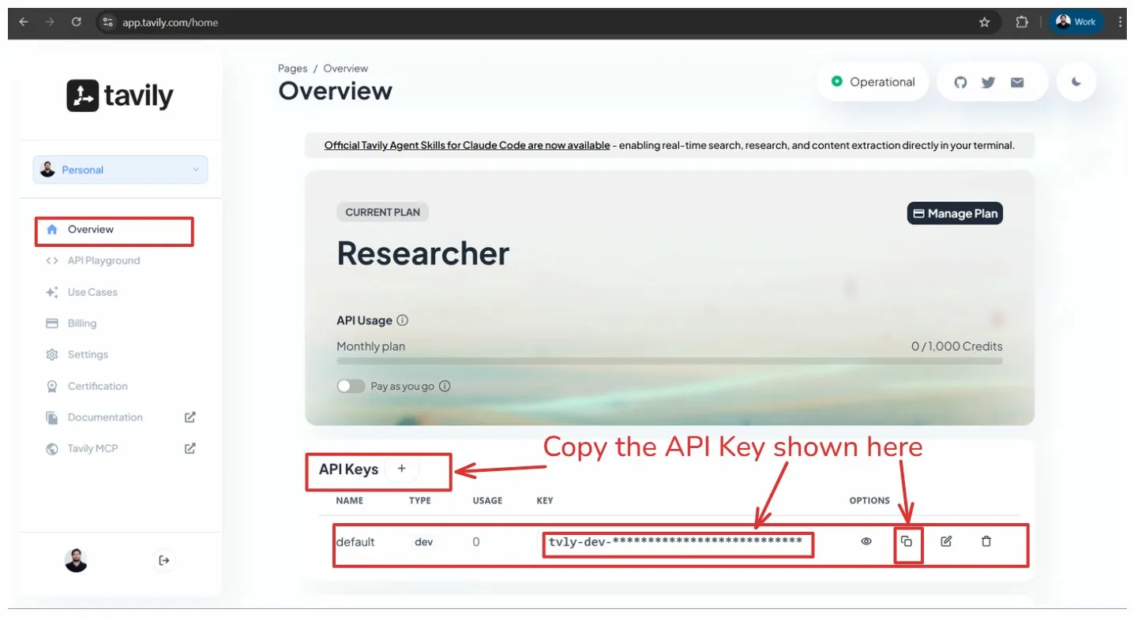

Step 4 | Create a New API Key (Optional)

4.1 To create an additional API key, click the "+" (plus) button next to the "API Keys" heading.
4.2 In the creation form, enter a unique Key Name to identify this key (e.g., "Project_1").
4.3 Select the Key Type based on your environment:
Development — Rate limited to 100 requests/minute (recommended for testing)
Production — Rate limited to 1,000 requests/minute (for live applications)
4.4 (Optional) Check "Limit monthly usage" and set a credit limit (e.g., 1000) to control spending.
4.5 Click the "Create" button. Your new API key will appear in the API Keys list and is ready to use.

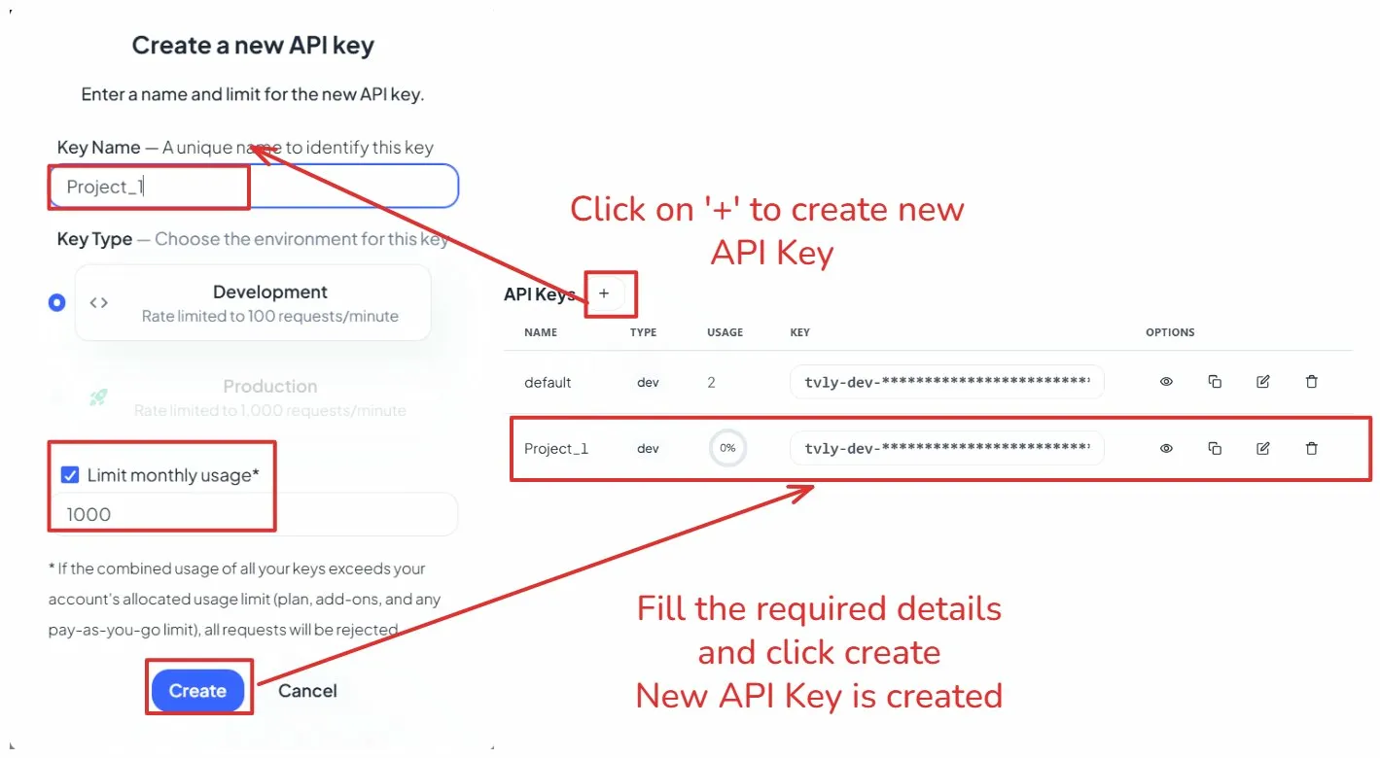

Summary
Step | Action
Step 1 | Navigate to tavily.com and click "Sign Up"
Step 2 | Create your account using Google, GitHub, or email
Step 3 | Copy the default API key from the Dashboard Overview
Step 4 | Optionally create additional API keys for different projects

You are now ready to integrate Tavily Search API into your applications!
For API documentation, visit: docs.tavily.com

OpenAI API Key – Allowed Models & Troubleshooting
Allowed Models
Your Interview Kickstart OpenAI API key provides access to the following models. Please use only these models for the course projects:
- gpt-4o-mini
- gpt-4o
- tts-1
- whisper-1
- omni-moderation-latest
- text-embedding-3-small
- text-embedding-3-large
- text-embedding-ada-002
Please test your project before the class
We recommend running the project once before the live class by following the provided instructions. This will help you identify and resolve any setup or configuration issues in advance.
If you face a rate limit or quota error during the class:
When multiple learners run the same models simultaneously, some models may temporarily experience high usage. You may see errors such as “Rate limit exceeded” or “Quota exceeded.”
If you encounter these errors:
- Wait for 5–10 minutes and try running the project again.
- Your API key has sufficient credits for the course projects, so please do not worry about the error immediately.
- If the issue continues, try running the project again after the class.
If your API key appears to be invalid or is not working:
You can verify your API key using the OpenAI API Key Tester:
OpenAI API Key Tester: https://trevorfox.com/api-key-tester/openai/
If the key is still not working after verification, please contact the Operations team for support.

